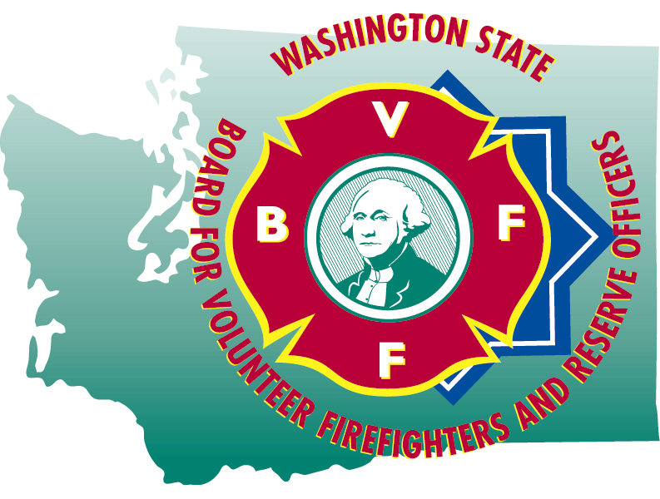
HAILEY BLANKENSHIP
Executive Secretary

STATE OF WASHINGTON

BOARD FOR VOLUNTEER FIREFIGHTERS & RESERVE OFFICERS
PO Box 114•Olympia WA 98507•(360) 753-7318•FAX (360) 586-1987•Toll Free (877) 753-7318
Website:www.bvff.wa.gov

Martin Spani
Board Chair

October 23, 2023

STATE OF WASHINGTON

BOARD FOR VOLUNTEER FIREFIGHTERS & RESERVE OFFICERS
PO Box 114•Olympia WA 98507•(360) 753-7318•FAX (360) 586-1987•Toll Free (877) 753-7318
Website:www.bvff.wa.gov

AGENDA

CALL TO ORDER

CORRECTIONS TO THE AGENDA

INTRODUCTION OF GUESTS

READING OF THE MINUTES OF THE July 23, 2023 REGULAR MEETING

FIRST HEARING OF THE PUBLIC PRESENT

OLD BUSINESS

- Update of the database project
- Update on the IRS filing and PLR ruling
- Update on the Alan Basso LODD benefits- continues to be tabled
NEW BUSINESS

- Discussion and presentation with WSIB
- Discussion and presentation with OSA
- Discussion and action to set 2024 disability and pension fees for EMSD and RO’s
- Discussion and action to set 2024 retire/rehire surcharge
- A review of the 2023 Annual Survey Results
- Review of Permanent Partial Disability award
  - Glenda Palmer
  - Greg Laycock
- Update on the biennial Accountability Audit
- Discussion and action to set 2024 Board meeting dates
- Review of the Secretary’s leave and pay records
- Review of administrative expense vouchers

- Review and approval of retirement forms

GOOD OF THE ORDER

SECOND HEARING OF THE PUBLIC PRESENT

MOTION FOR ADJOURNMENT

